**EEG brainscan to control robots**

Here are a few notes from my research, It is very disordered and not be taken as anything official. It can help better understand why I did certain things the way I did them.

For mobility robots we use a blend of listening to the brain of the user and the robot intelligence to determine the best choices

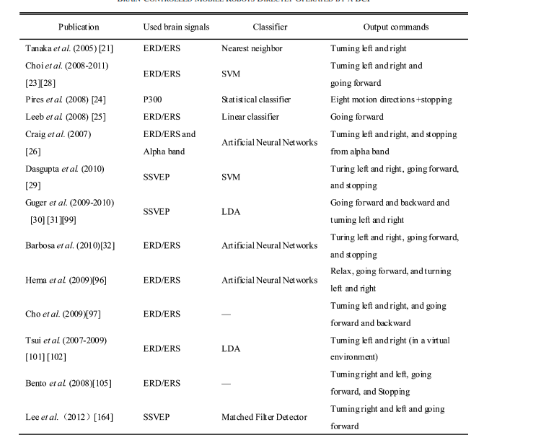

In the real world could be an issue as there are many unexpected things happening and it can be distracting

Syncrhonus bci take a lot of time to train and are not as precise as synchronous bci

Two additional types of brain signals that are used to develop brain-controlled mobile robots are

1. error-related potential (ErrP), which occurs after a user becomes aware of an error made by himself/herself or by another entity and 2) the synchronization of alpha rhythms, which significantly occurs in the visual cortex when the eyes are closed

P300, SSVEP and ERD/ERS are the three main brain signals used for bcis

Preprocessing: The simplest and most widely used method

to remove artifacts is filtering including low-pass, high-pass,

band-pass, and notch filtering, which is appropriate to remove

line noise and other frequency-specific noise such as body movement. However, this method filters useful components of EEG

signals with the same frequency band as artifacts. Independent

component analysis (ICA), which is a computational method to

divide a mixed signal into its statistically independent components, is another approach frequently used to eliminate artifacts

of EEG signals, and many studies have demonstrated its efficacy

in removing these artifacts [76]–[83]. In the brain-controlled

mobile robot of [23], ICA was used to remove artifacts. However, ICA is difficult to use, and algorithmic complexity is high,

compared with filtering. That is why almost all of the existing

brain-controlled wheelchairs used filters to eliminate artifacts.

Additional methods to remove artifacts such as wavelet transform can be seen in [84] and [85]

DL frameworks like Convolutional Neural Network (CNN) [7], Long Short-Term Memory

(LSTM), Deep Belief Network (DBN) and Stacked AutoEncoder (SAE) have been applied for decoding and classification of MI signals

The most common input formulation found to be used during our study was time-frequency STFT image representation, transforms 1D EEG [11] signals into 2D time-frequency representation. In addition, other input formulation such as, CTW, PSD, CSP filter had shown to support for the best classification of motor imagery. It was found that image representation of input data was common input formulation choice for MI classification.

CNN was the most prominent DL architecture, covered around 73% of the total number of the studies, as it composed of convolutional layer (kernel or filter), pooling layer (sub-sampling) and fullyconnected layer.

that LSTM was the most prevalent RNN choice for the classification of motor imagery

Hybrid architectures such as LSTM and CNN, CNN and SAE, DBM and AE, CNN and CDDLC were commonly used mixed architectures for classification of MI. Among the hybrid architectures, the hybrid CNN, has shown good performances, specifically CNN and CDDLC (95.3%), which outperformed other DL hybrid architectures.

Although

BCI based on motor imaging has proven efficacy in stroke

patient treatment, their usage in clinical practice has been

limited due to poor performance, non-flexible properties,

and extensive training periods

A novel method for classifying Motor Imagery (MI) in

Brain-Computer Interface (BCI) systems based on multivariate variation mode decomposition (MVMD) has been

employed [60]. By decomposing the data into intrinsic mode

functions, the approach tries to extract discriminative features

from MI EEG signals

• Filtering: EEG signals are often contaminated with

noise and artifacts. Filtering techniques such as high

pass, low pass and notch filters [18], [26] are used to

remove unwanted frequency components and improve

signal quality.

• Artifact removal: Techniques such as Independent

Component Analysis (ICA) and Principal Component Analysis (PCA) are used to separate and remove

artifacts such as eye blinks, muscle activity and electrocardiogram (ECG) interference [28], [29], [31].

• Time Domain Features: Features such as mean amplitude, root mean square value, and signal variance are

extracted to capture the temporal characteristics of

EEG signals [47], [48], [51], [53].

• Frequency domain properties: Power spectral density,

spectral entropy, and band power ratios provide insight

into the frequency distribution of brain activity [11],

[17], [18].

• Time-frequency characteristics: Techniques such as the

wavelet transform and the short-time Fourier transform

reveal how the characteristics of the EEG signal vary in

time and frequency [23], [57], [61].

• Functional connectivity: Measures such as coherence,

phase synchronization, and mutual information assess

the functional relationships between different brain

regions [51], [52], [54].

• Graph theory analysis: EEG data can be represented as networks, and graph theory metrics reveal

organizational and communication patterns in the

brain [64], [69].

• Pattern recognition and motor imagery: EEG signals

captured during motor imagery tasks are processed to

recognize specific patterns associated with imagined

movements. These patterns can be used to control

external devices [59], [60], [65], [72].

Discriminative models

◦ Representative models: autoencoders Several researchers in this

study used non-DL data augmentation procedures,

including noise addition [11], sliding window [8],

and amplitude perturbation [13], to enhance the

quantity of training data. Two of the research evaluated [64], [67] used GAN and VAE networks

for DL-based data augmentation. These studies

found that utilizing GAN models for MI data

augmentation considerably improved classification performance.

Performance indicators:

Classification accuracy: In tasks such as motor

imagery classification or cognitive state detection, classification accuracy measures how well an EEG-based

model can distinguish between different classes or

states [11], [13], [17], [21], [26], [27], [32], [47], [48].

• Receiver operating characteristic (ROC) curve and

area under the curve (AUC): ROC curves and AUC

values are used to evaluate the trade-off between sensitivity and specificity in classification tasks [26], [29],

[33], [54].

• Mean Squared Error (MSE) or Root Mean Squared

Error (RMSE): This metric measures the difference

between the predicted and actual values, often used

in regression functions to measure the accuracy of the

prediction [13], [43], [46], [53], [63].

• R-squared (R2) or coefficient of determination: R2

measures the amount of variation in the dependent

variable that can be predicted from the independent

variables. It shows how well the regression model fits

the data [56], [57], [59], [61].

• Real-time performance metrics: For real-time applications, metrics such as response latency, response time,

and overall system latency are evaluated [55], [59],

[60], [61], [63], [65].

Improving the Separability of Motor Imagery

EEG Signals Using a Cross Correlation-Based

Least Square Support Vector Machine for

Brain–Computer Interface

LS-SVM

evaluated

with classification accuracy through a 10-fold cross-validation

procedure

The

proposed scheme develops a novel cross-correlation based feature

extractor, which is aided with a least square support vector machine (LS-SVM) for two-class MI signals recognition

The experimental results using the proposed algorithm are

consistent because the parameter values of the LS-SVM

classifier are optimally selected through the two-step grid

search algorithm rather than by the manual selection

Active Data Selection for Motor Imagery

EEG Classification

efficient decoding around the motor cortex, which leads to practical biomedical applications in

rehabilitation and neuroprosthesis

well-known method to extract the brain activity for the MIBMI is the common spatial pattern (CSP) [1], [14], [15]. The

CSP is a set of spatial weight coefficients corresponding to each

electrode in a multichannel EEG. These coefficients are determined from measured EEG data in such a way that the variances

of the signal extracted by the spatial weights differ greatly between two tasks (e.g., left and right hand movement imageries). Check this paper for math functions to create cov matrix and var and stuff like this.

EEG Source Imaging Enhances the Decoding

of Complex Right-Hand Motor Imagery Tasks

Describes how they create dataset and explain step by step how to classify.

Using ESI techniques

A Channel-Projection Mixed-Scale

Convolutional Neural Network for

Motor Imagery EEG Decoding

CP-MixedNet including the CP-Spatio-Temporal block,

the MS-Conv block, and the classification block

In summary, we propose a CP-MixedNet with amplitudeperturbation data augmentation method for motor imagery

EEG decoding. Specifically, the CP-MixedNet first utilizes the

CP-Spatio-Temporal block to process the multi-channel EEG

signals and further extract the spatio-temporal representation.

Then the MS-Conv block is employed to extract different

time-scale information. Finally, the classification block outputs

the classification results.

Multi-Scale Convolutional Attention and Riemannian Geometry Network for EEG-Based Motor Imagery Classification

B. PERFORMANCE METRICS Accuracy and Kappa score are considered important indicators in MI-EEG signal classification, which is defined as follows: ACC = Pn i=1 TPi ÷ li n (10) where ACC is accuracy, n indicates the number of classes, TPi is the abbreviation for true positive which means the number of correctly predicted samples in class i, and li is the number of samples in class i. k_score = 1 n Xn a=1 Pa − Pe 1 − Pe (11) where k_score is Kappa score, Pe is the expected percentage chance of agreement, Pa is the actual percentage of agreement, and nis the number of classes.

EEG-Channel-Temporal-Spectral-Attention

Correlation for Motor Imagery EEG Classification

1) We propose a novel wavelet-based temporal-spectralattention correlation coefficient (WTS-CC) to achieve

more accurate MI EEG discrimination by simultaneously

considering the features and their weighting in spatial,

EEG-channel, temporal, and spectral domains.

2) The Deep EEG-channel-attention (DEC) module is proposed to automatically adjust the weight of each EEG

channel according to its importance, thereby effectively

enhancing more important EEG channels and suppressing less important EEG channels.

3) The wavelet-based temporal-spectral-attention (WTS)

module is proposed to obtain more significant discriminative temporal-spectral-attention features on twodimensional time-frequency maps between different MI

tasks.

4) The experimental results indicate that the proposed

WTS-CC method achieves promising performance in

comparison with the state-of-the-art methods in terms

of classification accuracy, Kappa coefficient, F1 score

and AUC on three public datasets

iTFE module, DEC module, WTS module and Discrimination

module.

Motion Artifacts Suppression From EEG Signals

Using an Adaptive Signal Denoising Method

) A hybrid method based on self-adaptive EMD, and

optimized LoG filter is proposed to suppress motion

artifacts from EEG signal.

2) The soft adaptive sifting stopping criterion is defined

with the help of an objective function. The objective

function is optimized by minimizing the signal characteristics without prior knowledge of threshold values to

determine the optimum number of IMFs.

3) The optimized LOG filter is formulated by the minimization of the mean absolute error in power spectral

density (MAE-PSD) for the δ-bands between noisy and

denoised EEG signals.

4) Extensive performance comparison of existing state-ofthe-art EEG signal denoising algorithms and the proposed method has been studied using EEG signals from

three publicly available EEG datasets (synthetic as well

as real) for the suppression of motion artifacts

eight different performance assessment metrics are

as follows: difference in signal to noise ratio (

SNR), signal to artifact gain coefficient (γ ), mean absolute error in

PSD of δ-band (MAEδ

PSD), mutual information (MI), percentage improvement in correlation [

corr (%)], percentage

improvement in coherence [

coh(%)], power spectral distortion [

PSDdis (%)] and execution time. These metrics are

calculated from the given noisy EEG[x(n) ∈ 1×N ], reference

EEG[xref(n) ∈ 1×N ], and denoised EEG[xd(n) ∈ 1×N

Total Variation Denoising techniques for artifact

removal from EEG signals

Total Variation Denoising techniques for artifact

removal from EEG signals

It has been observed that

TARA outperformed Simultaneous LPF/TVD in denoising

the EEG signals

Wavelet Based Waveform Distortion Measures for

Assessment of Denoised EEG Quality With

Reference to Noise-Free EEG Signal

Without eog removal   
  
Mutual Information: 2.4611888371305493

SNR after denoising: 19.778233097596974 dB

Signal-to-Artifact Gain Coefficient (SAGC): -0.102926070202365

Mean Absolute Error in δ-band PSD (MAEδ_PSD): 0.6746438776634279

Percentage Improvement in Autocorrelation: -2.26%

Average Percentage Improvement in Coherence: 3438.1144006426202%

The time of execution of above program is : 38593.80388259888 ms

With eog removal and comparing after removal

Mutual Information: 2.2906515369307225

SNR after denoising: 18.387532541988474 dB

Signal-to-Artifact Gain Coefficient (SAGC): -0.13544558176351845

Mean Absolute Error in δ-band PSD (MAEδ_PSD): 0.4982411896929475

Percentage Improvement in Autocorrelation: -2.91%

Average Percentage Improvement in Coherence: 243769.7758696844%

The time of execution of above program is : 38750.818967819214 ms

With eog removal and testing before removal

Mutual Information: 0.8116742791561522

SNR after denoising: 4.634308286805485 dB

Signal-to-Artifact Gain Coefficient (SAGC): -1.6039394580657127

Mean Absolute Error in δ-band PSD (MAEδ_PSD): 4.823623660836044

Percentage Improvement in Autocorrelation: -29.57%

Average Percentage Improvement in Coherence: 5413.431380946737%

The time of execution of above program is : 31523.093223571777 ms